CSD 2550 – Web Applications and Databases

|  |  |  |
| --- | --- | --- |
| Name | Contributions to Project | Total Amount of Work on a Scale from 0 to 10 |
| Humzah M00492618 | * Front end of the website (and PHP) * Report-Description of Front end of website | 10 |
| Abdul  M00495457 | * CSS PHP * Wrote the description of MongoDB, * design database and * helped with the front end. | 10 |
| Shabbir M00506802 | * Design * Pictures * Video * Report | 10 |

We have decided to base our E-commerce website on watches as these timepieces play an important role such as making one more punctual, it can commemorate special occasions, and is also used to show how people express themselves for example putting on a nice watch is one of the perfect accessories after finishing off with a suite and tie. Smart watches allow you to use your phone without attracting attention and thus reducing the chances of being robbed. Some also enjoy collecting rare timepieces such as those from “Patek Phillipe, Jaeger LeCoultre Reverso, Kari Vouilainen and many more.

Below is a description of the website

**Status of the project so far:**

The project has reached a point where the front end is effectively finished, there is a possibility that some extra pages may need to be created in light of extra functionality which we may wish to incorporate in the website (such as an order confirmation page). But this will be relatively simple due to the css and php being already created.

**Header:**

Contains a **Title** for the current page, a mute button and shopping cart button below that is an animated **Navigation bar**, which displays the links for all the pages on the website

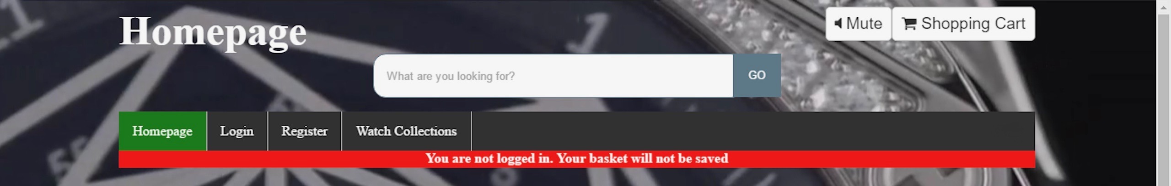

**Two banners header and footer:**

The header banner dynamically its changes colour and text depending on if a user is logged in or not. The footer banner contains a string "This website was created by Group 22 2017".



Footer



**Content:**

Contains the relevant content for the page will be placed. Is placed on a translucent text box.

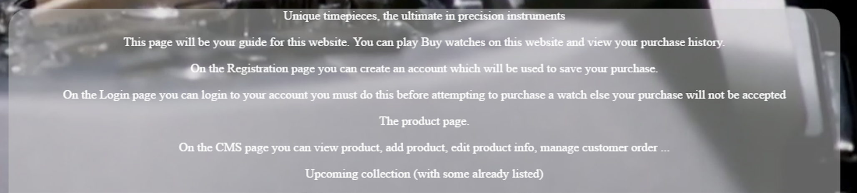

**Animated background:**

The background is a custom-made video/audio file made using Adobe Premiere Pro CS6. The video background hides the default video controls. However, the music can still be muted through the use of the mute button at the top of the page.



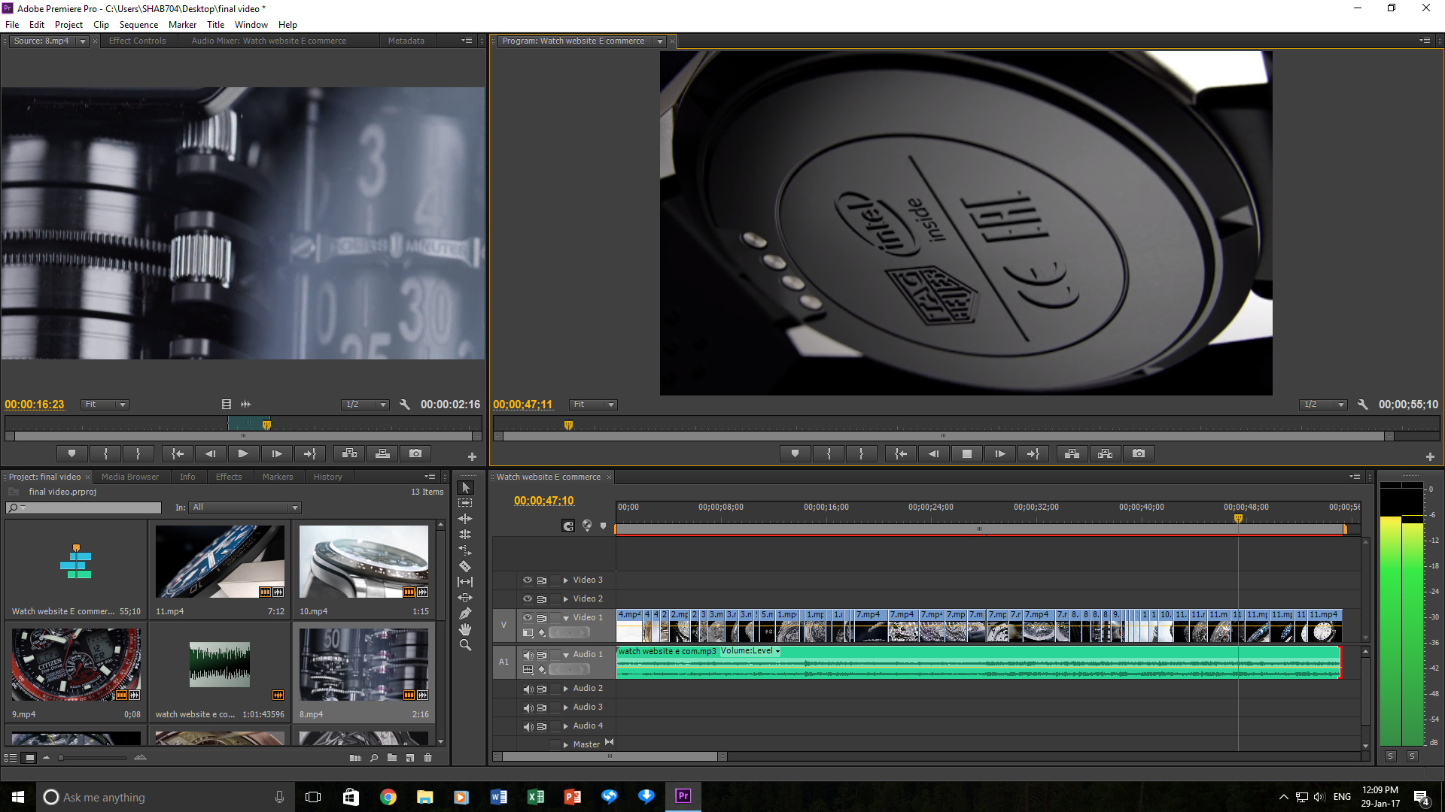

**Homepage:**  
The homepage will describe what content is on each page, and will help the user decide what pages they wish to go to.

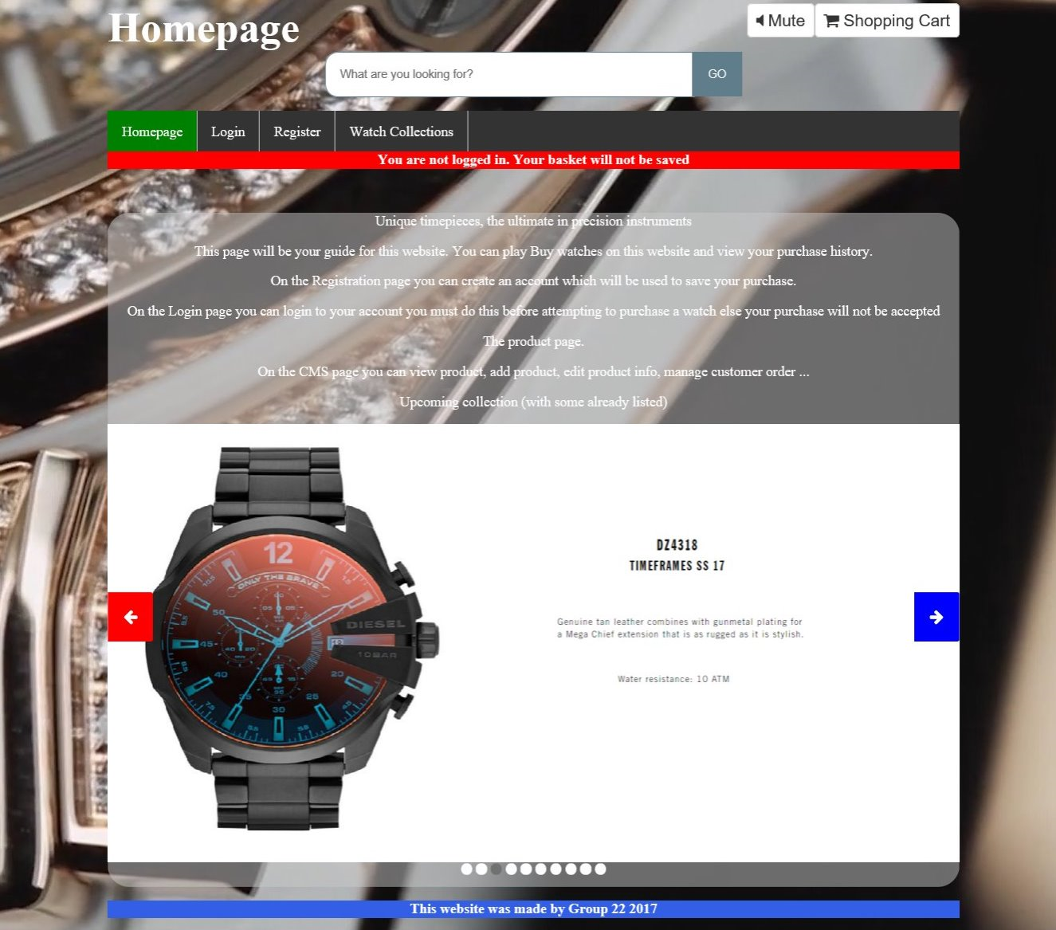

**Login:**   
The Login page will allow the user to login, but also links directly to the products page and to the registration page, should the user wish to bypass or postpone the login procedure.

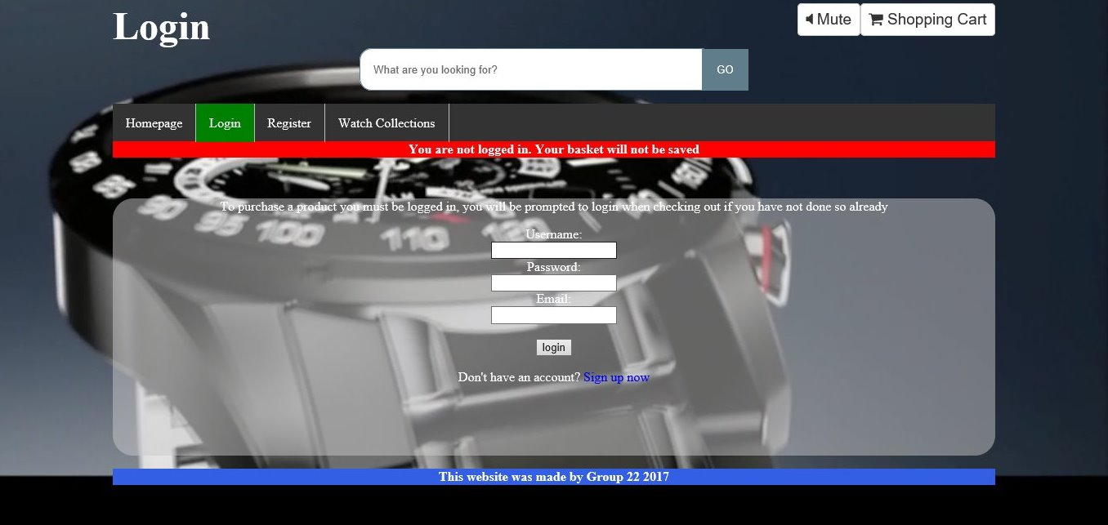

**Register:**

This page will allow the users to sign up for an account, but also links directly to the products page and to the login page, should the user wish to bypass the registration procedure.

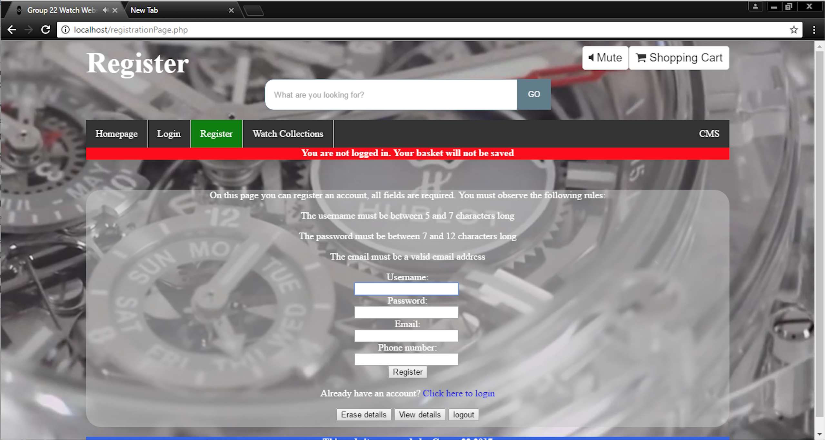

**Watch Collections:**  
This page allows the user to view the current range of watches we have for sale. Hovering over the image of a watch will replace the picture with a description. Users will be able to add items to their basket by clicking on the respective image.

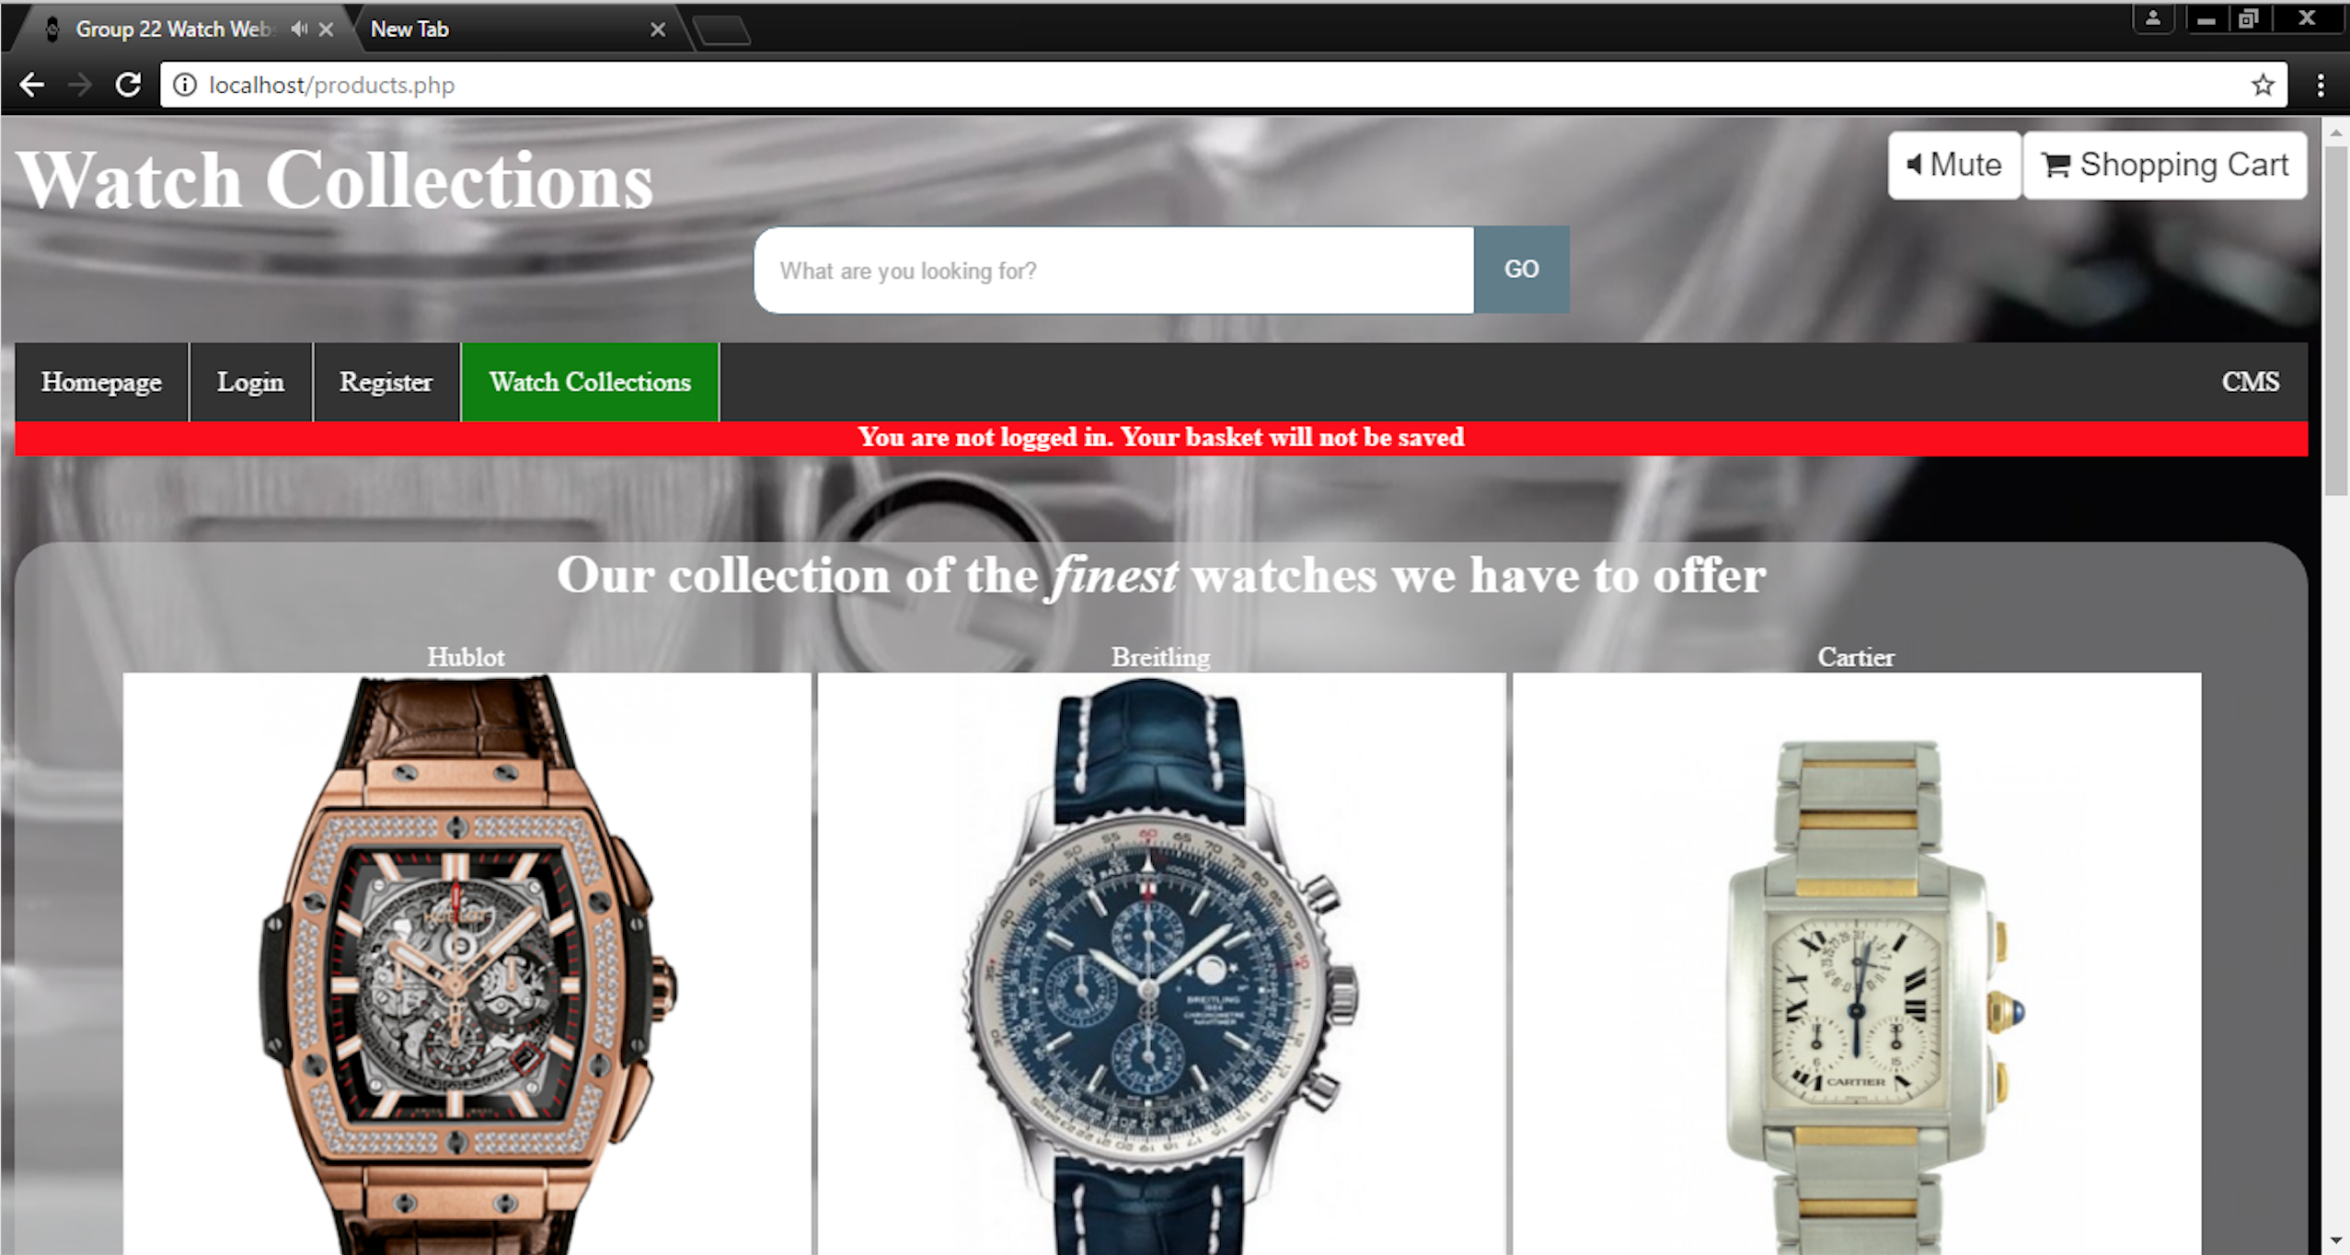

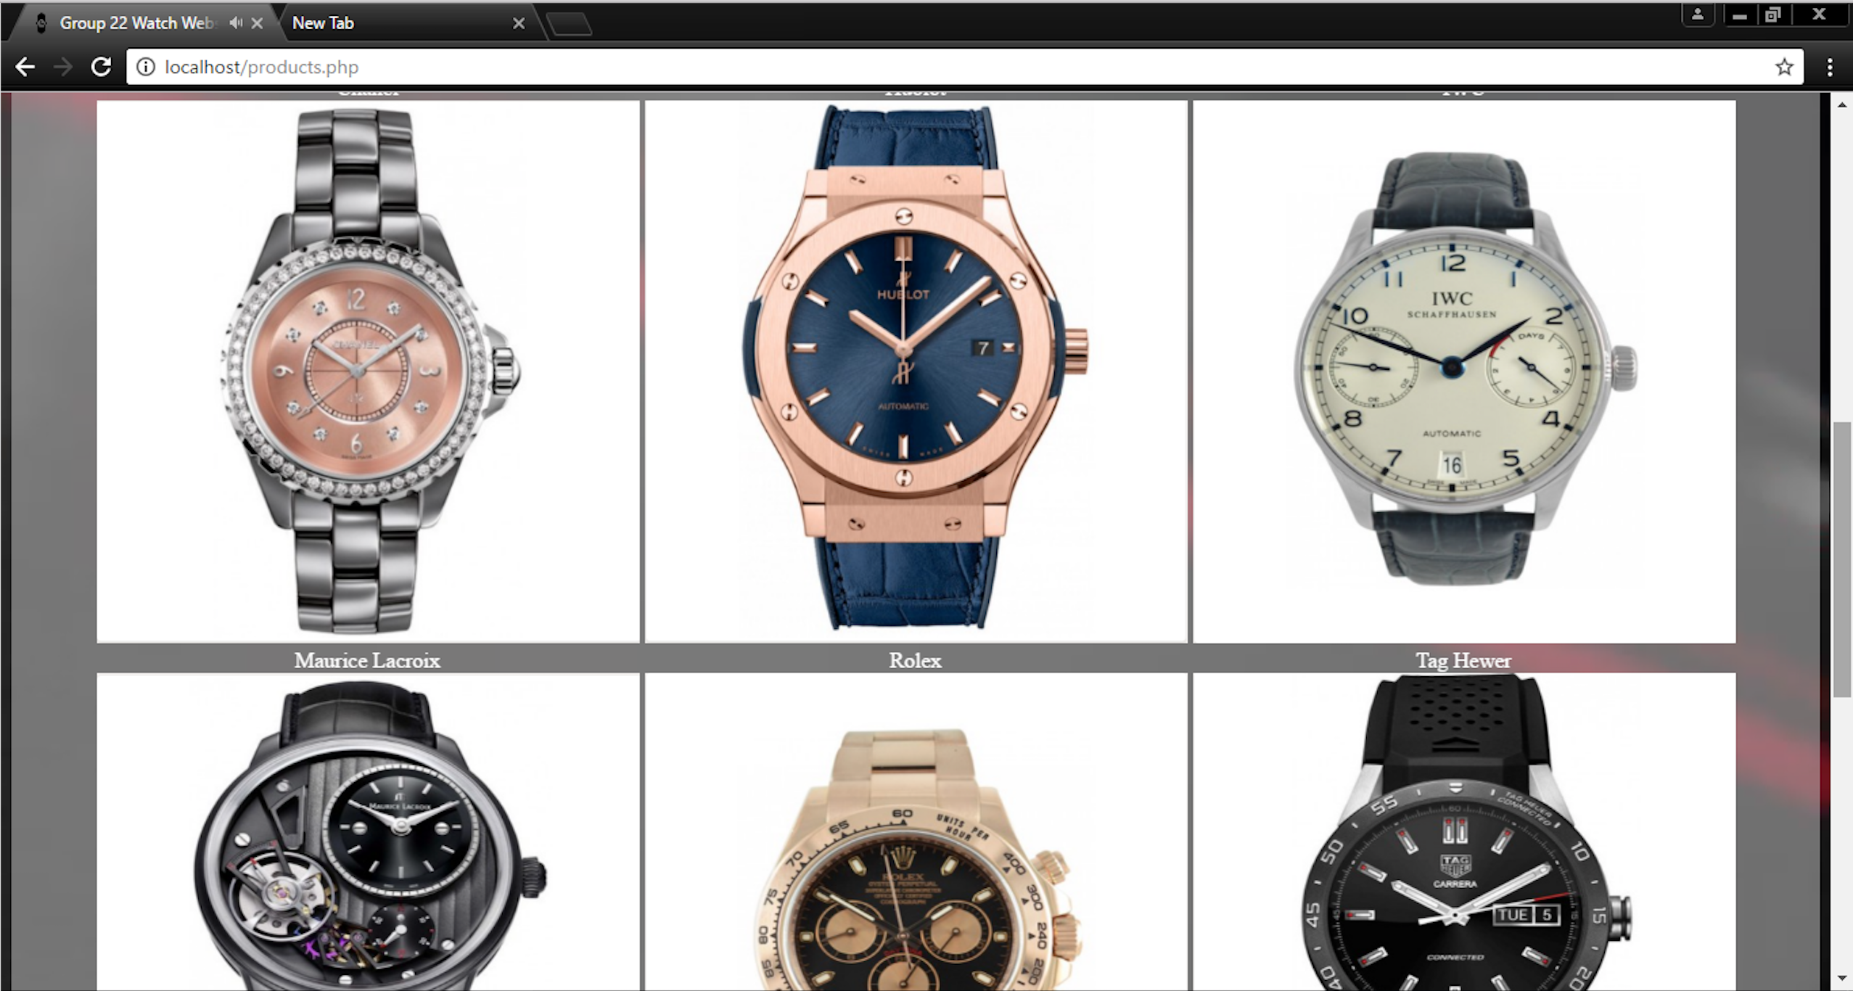

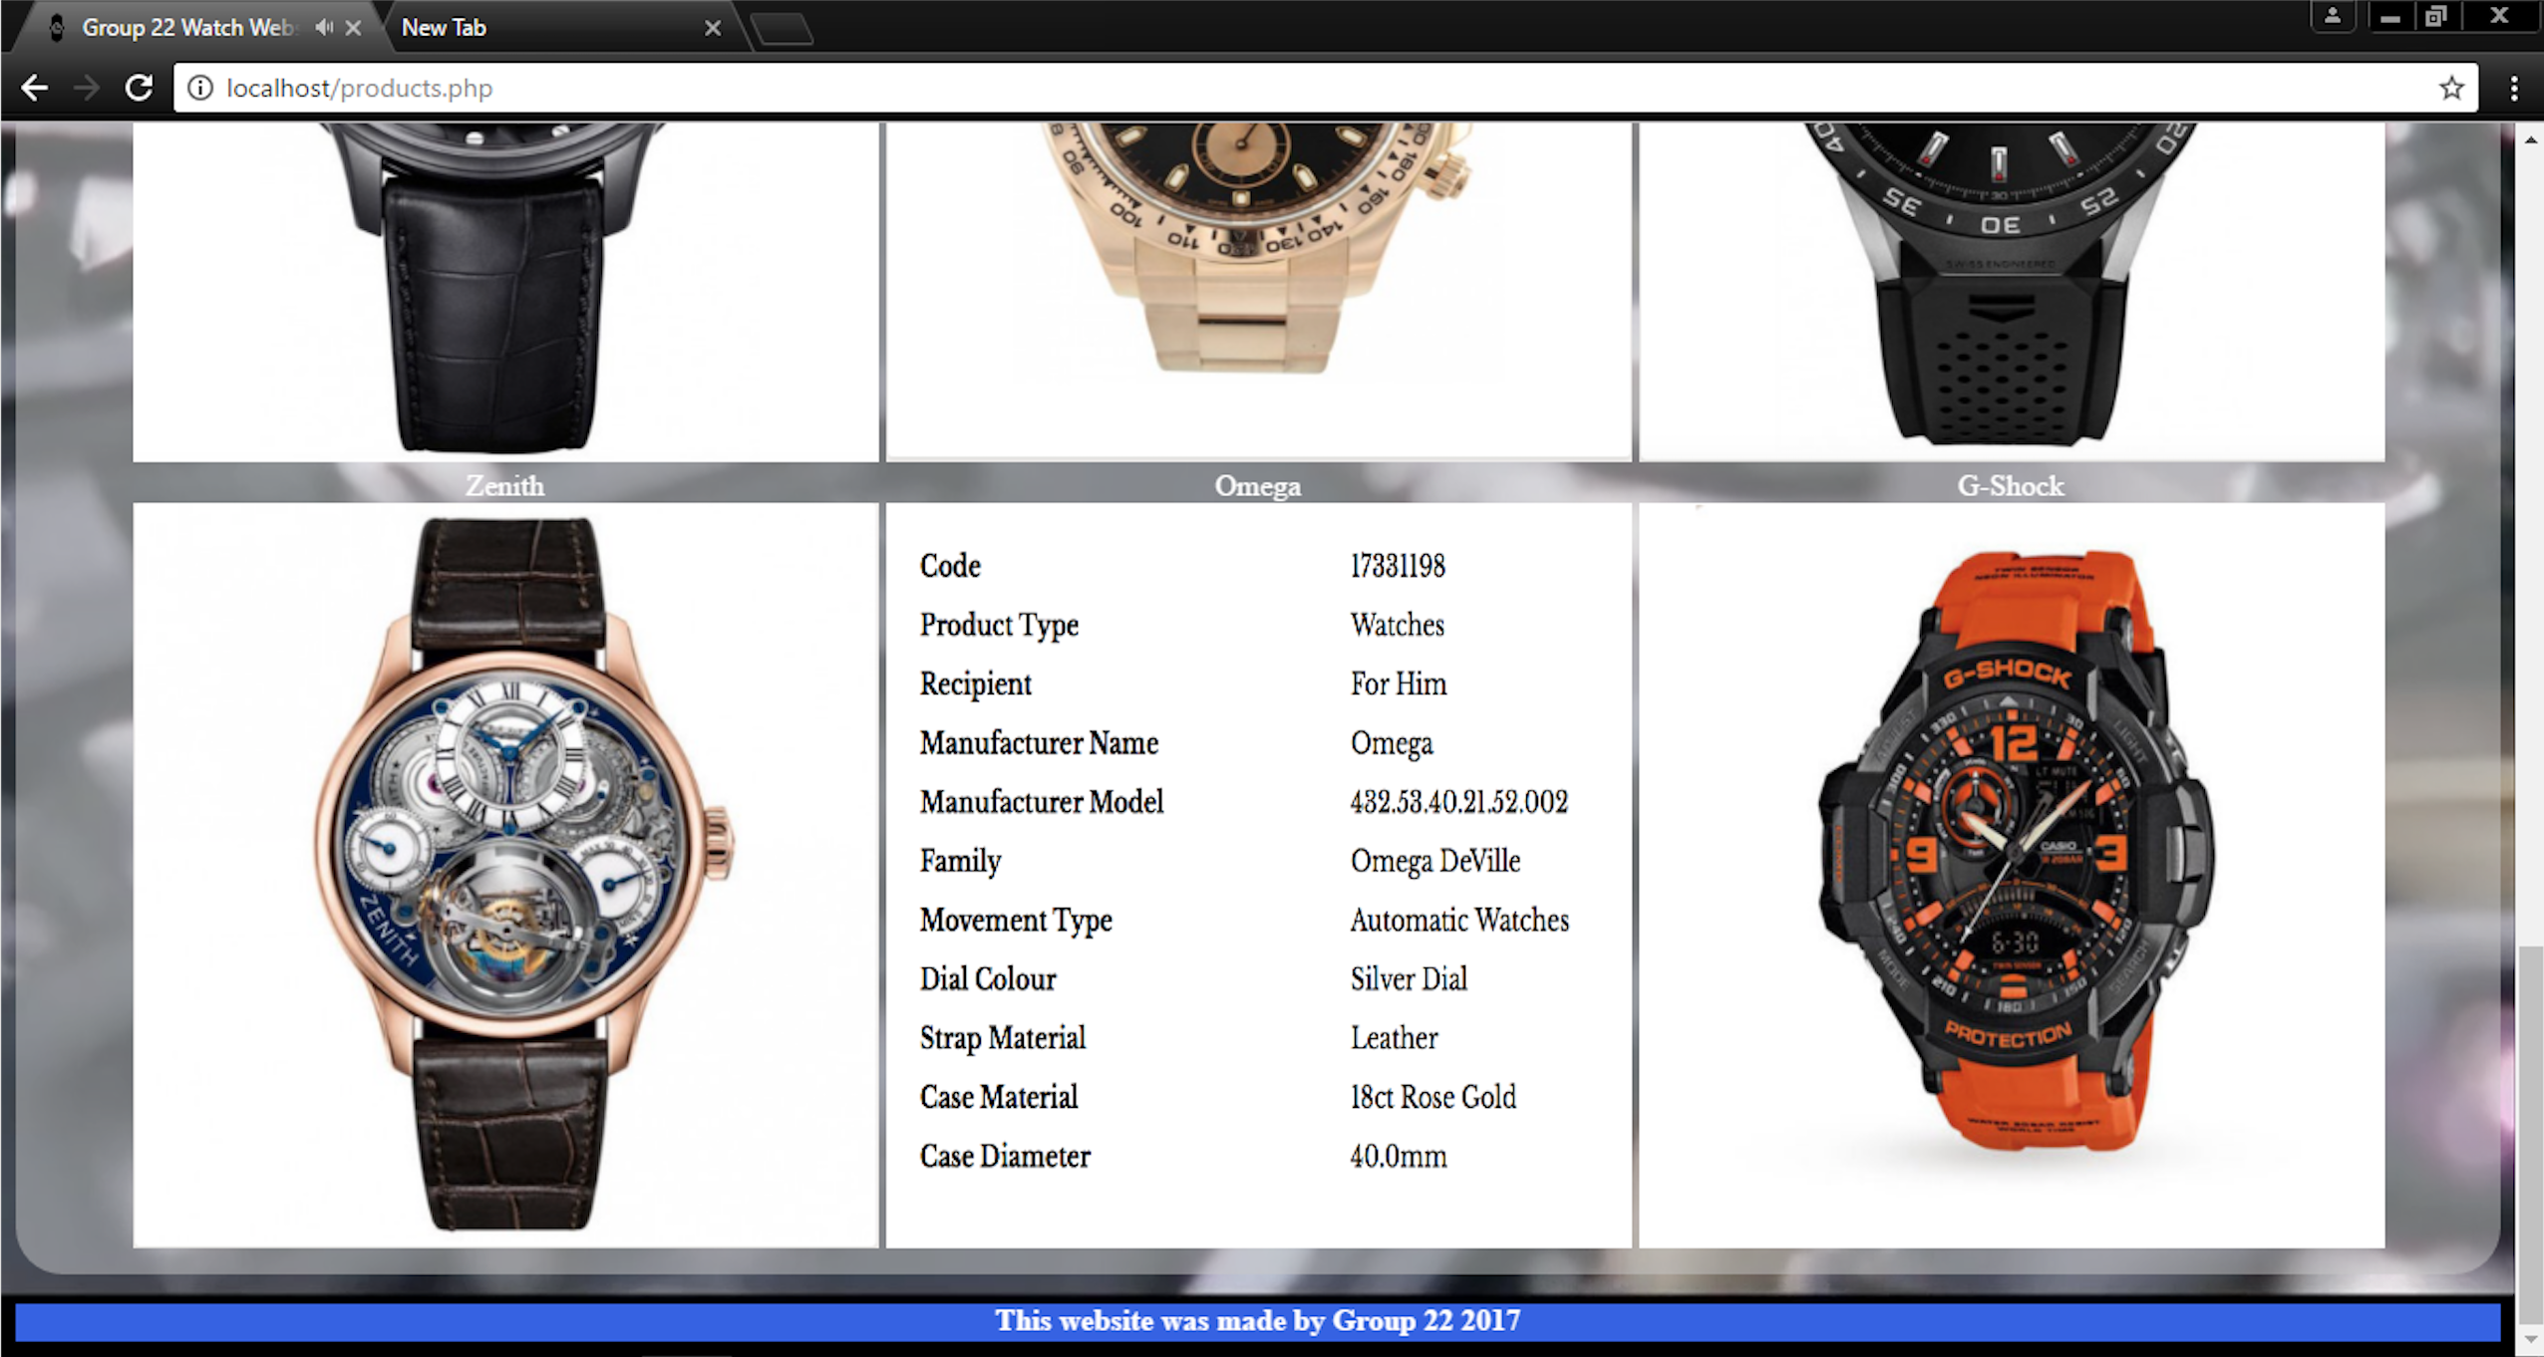

**Further information about Third party libraries:**

The only third party library used is Font Awesome (initially designed for Bootstrap, but can be used without it which is what we have done), to provide the icons seen on the mute and shopping cart buttons and search bar. In addition to the icons seen on the CMS page.

**MongoDB database Design and Description**.

**Customer**

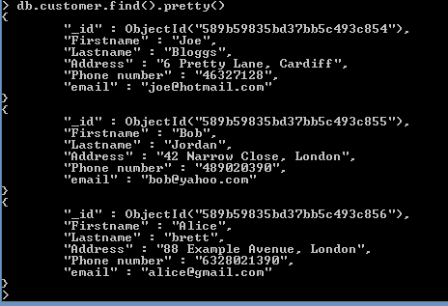

This is our customer collection which includes the name of the customer, address, phone number and email. Moreover, it important to have information about the customer as a result of login in and order product throughout the website.

**Product**

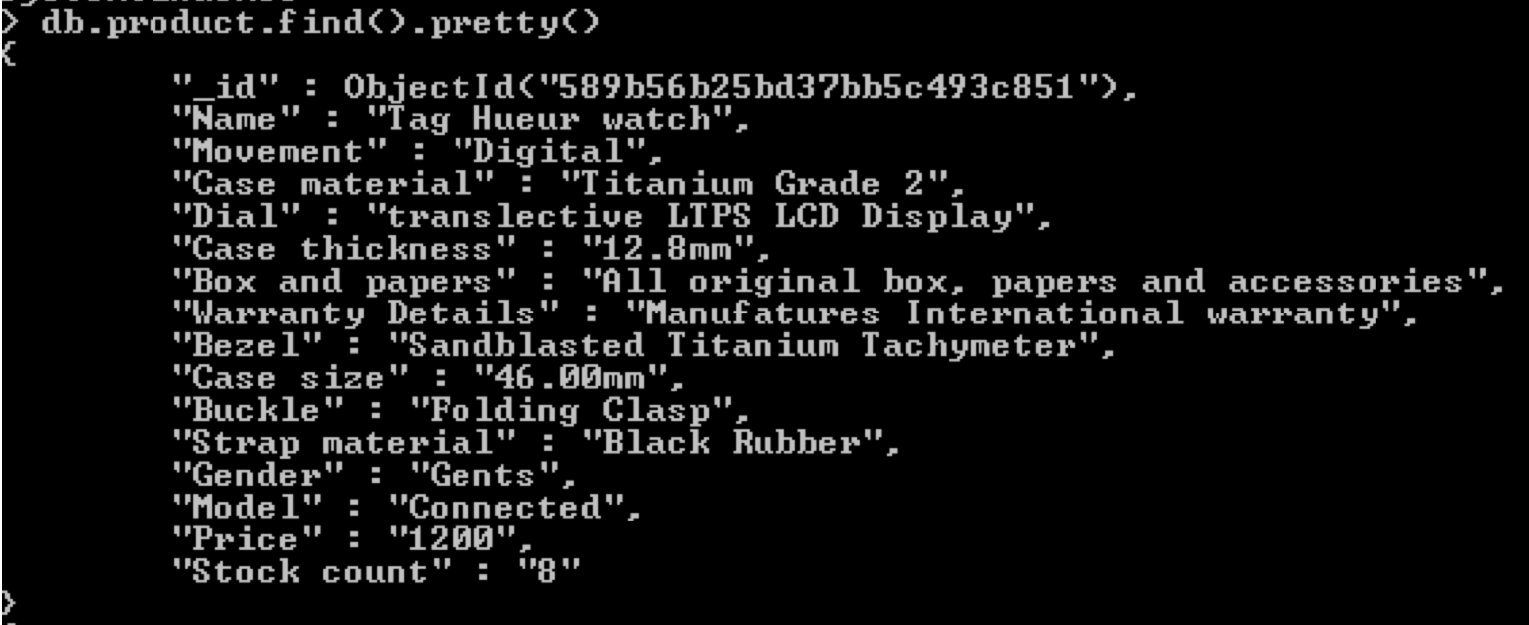

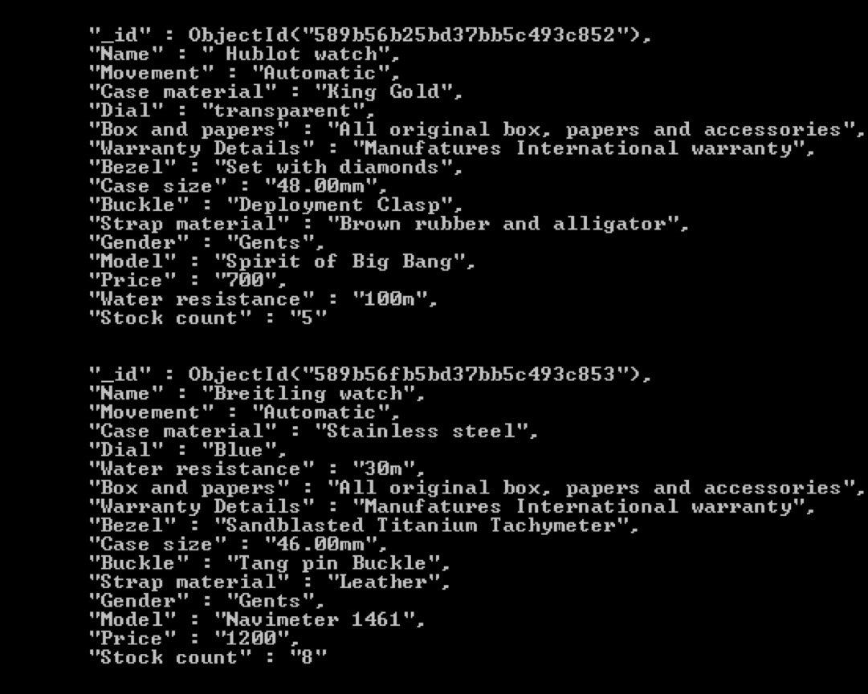

This is our products collection which includes name of the product, description and stock. Furthermore, product enable the customer to buy item in the website, according to our list the customer can look for product that are specific.

**Order**

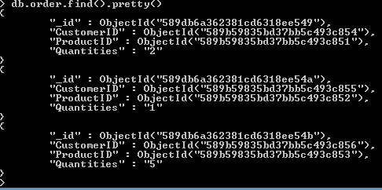

This is our order collection it includes the customer id, product id and quantities. The order is crucial in our website because it permit to give the proper product to the right client and the amount of product that the customer bought.

**Cart**

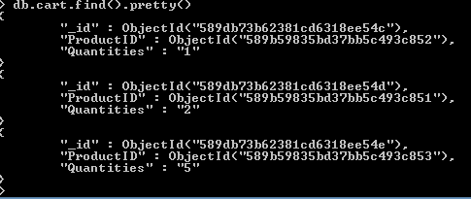

This is our shopping cart collection which include product ID, and quantities. Moreover, the shopping in important for the customer. He / She Enable to see what product the customer bought and how many.

**Other improvements added to the website**

**Regarding the basket**

Customers can add products to the basket

A confirmation pop up is then displayed and the order is then implemented in the database

**Searching for products**

Customers can sort via a different criteria ( example by price high to low or quantity low to high vice versa )

**Customer tracking and recommendations**

Customers who are logged in get recommendations based on their past orders, they can view their past orders and can update their details, and regarding those who are not logged in they only get recommendations for the most popular products.

**CMS**

This is used for the staff

Customer management system

Staff can log in and add products

View add and delete in addition to viewing customer orders

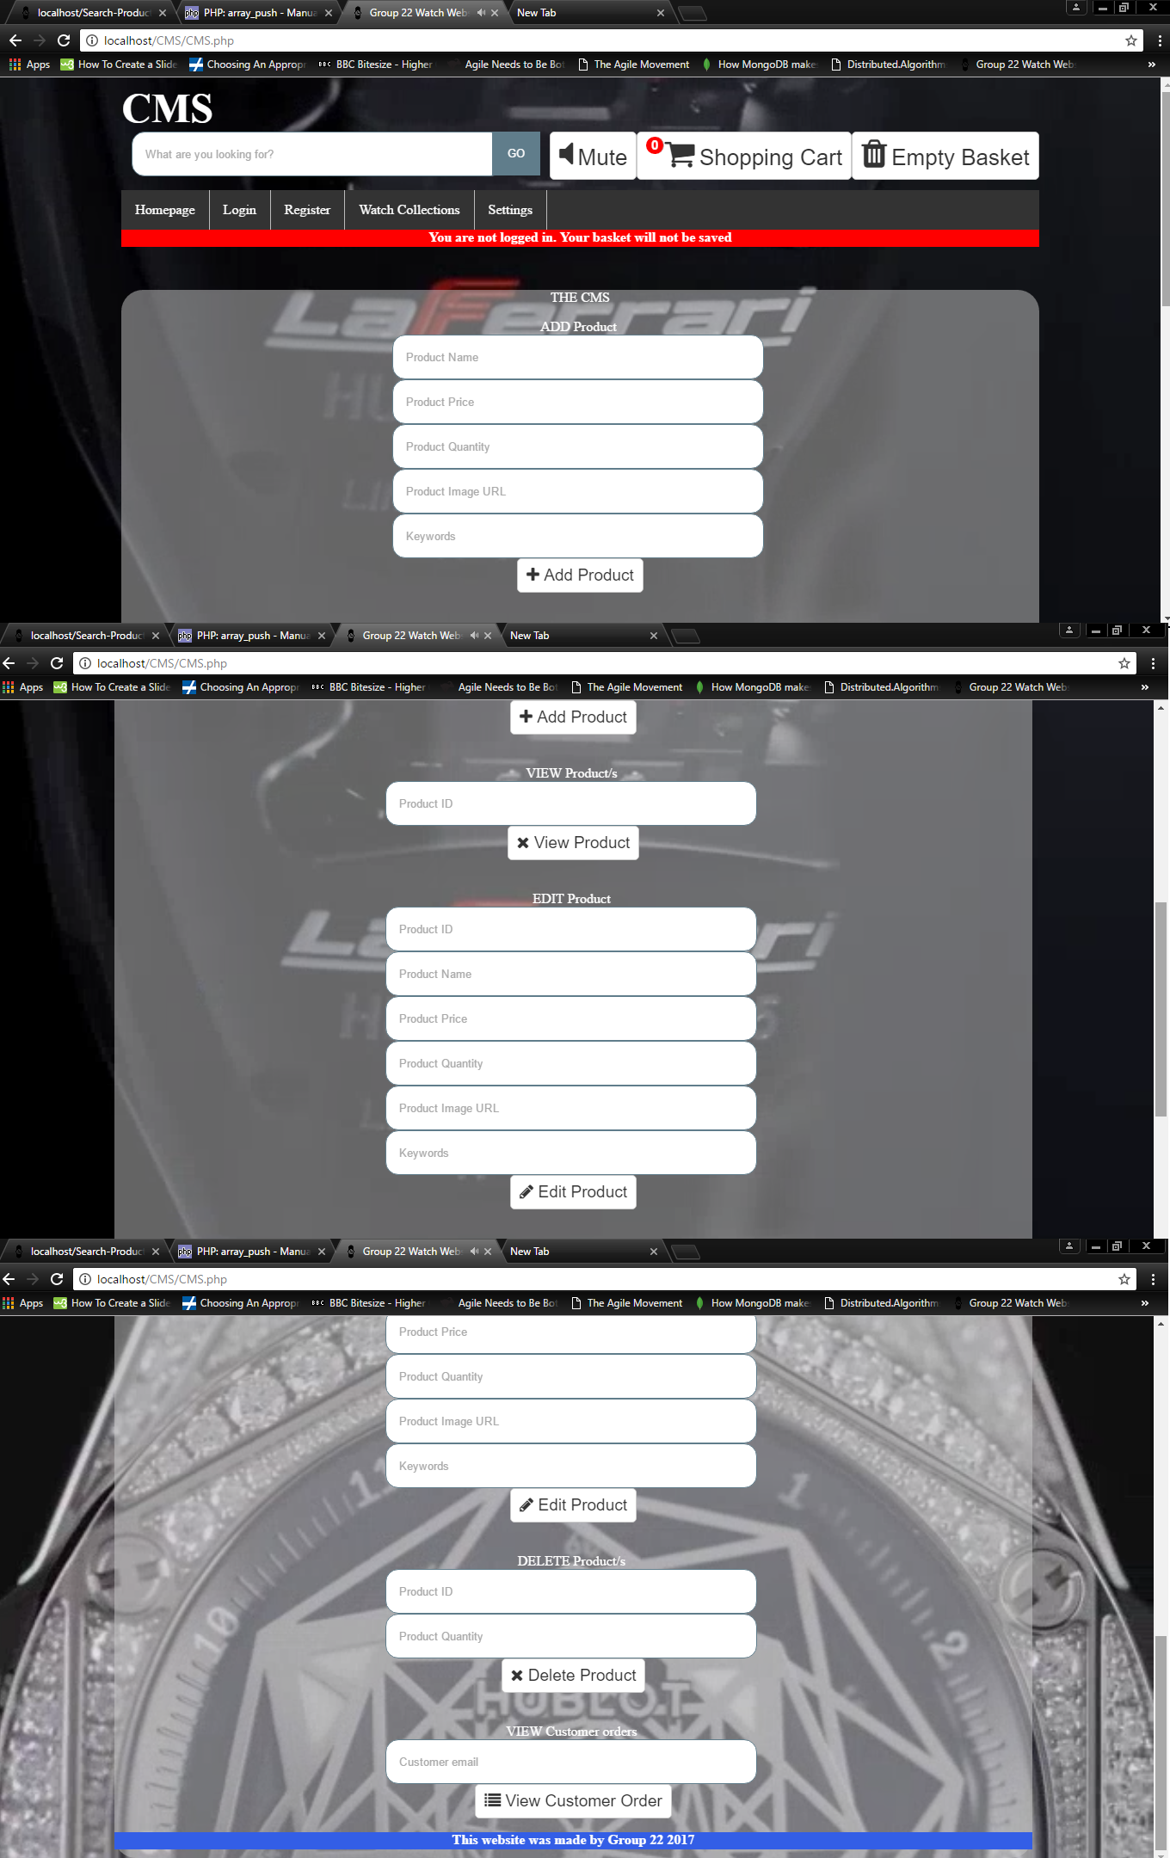

**AJAX**

This is the communication from the server to the customer which is used for the login, registration and recommendations.

Example in the figure below which shows the result of ajax communication between client and server

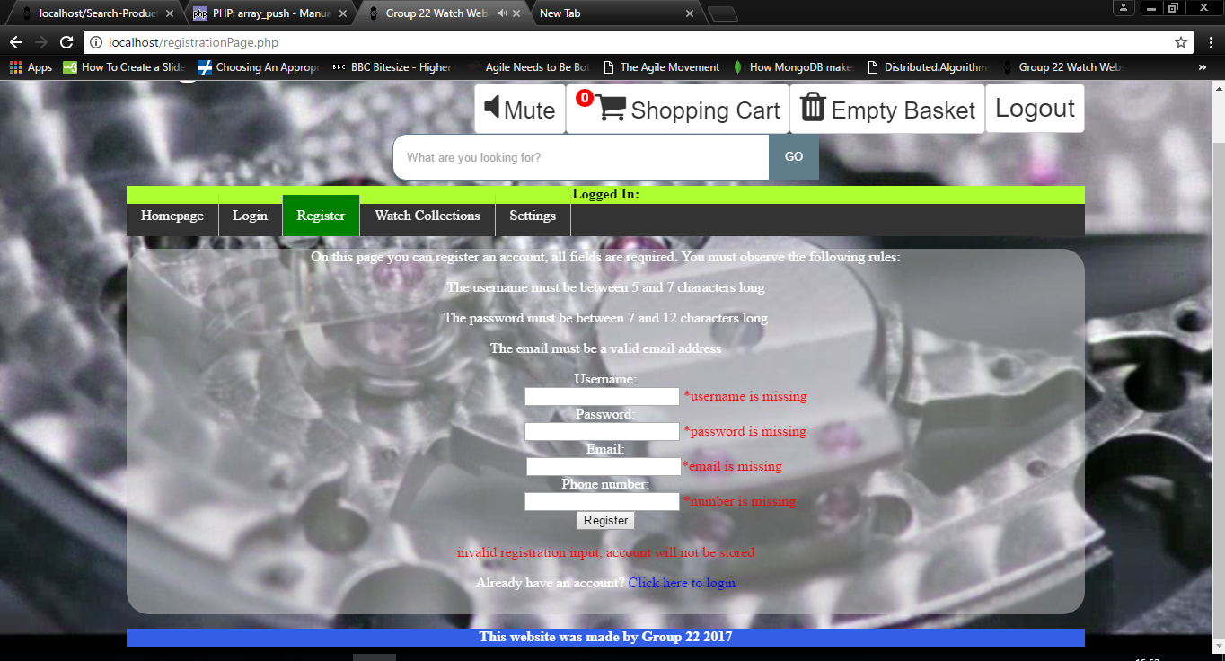

**Database**

In the following images it will show the Admin table, admin customer, keywords, orders and products.

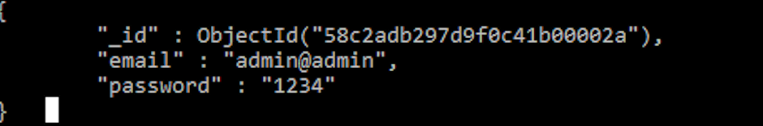

Admin Document

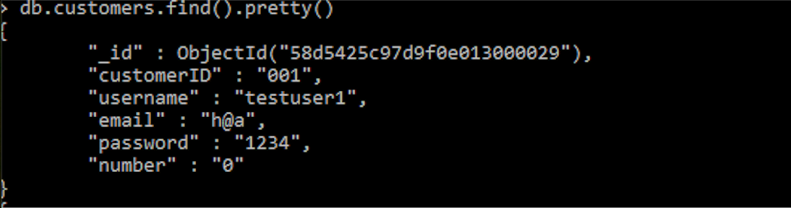

Customers

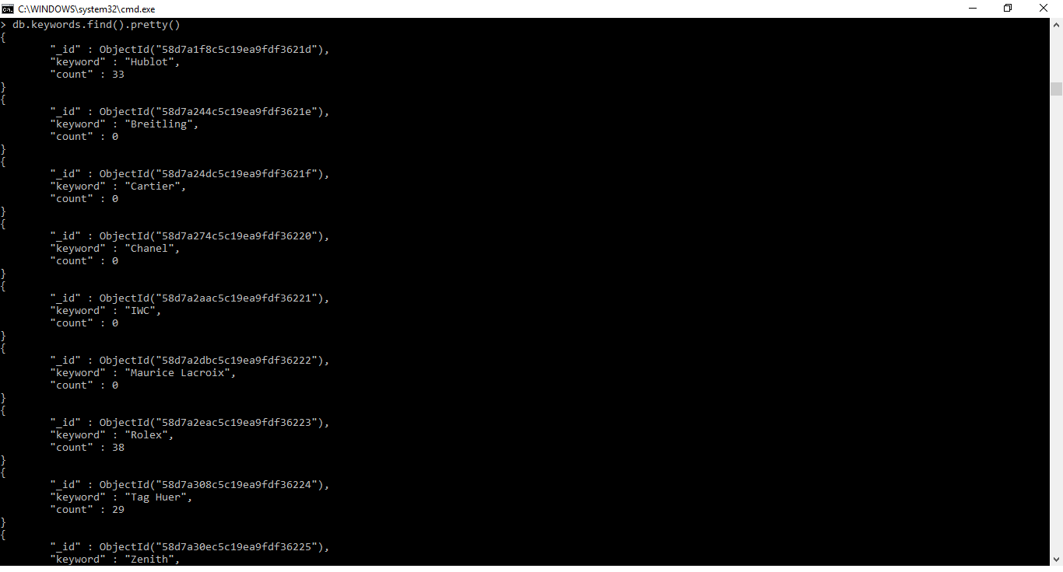

Keywords

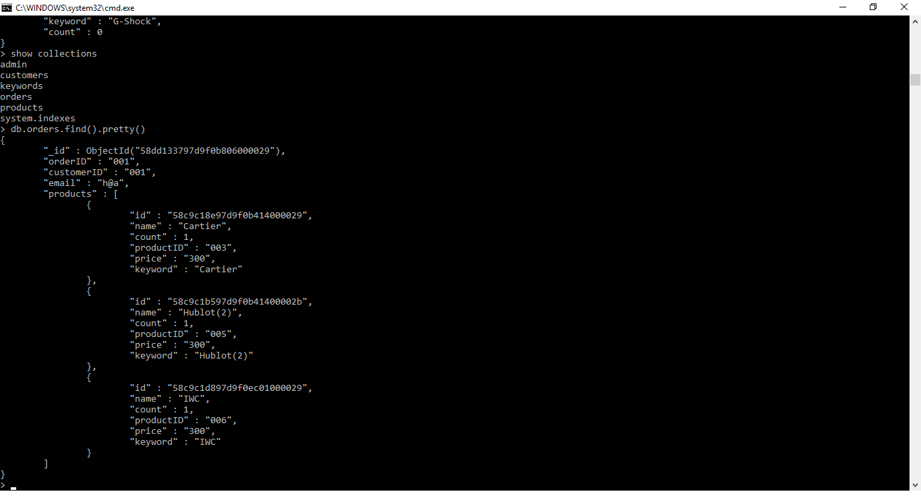

Orders

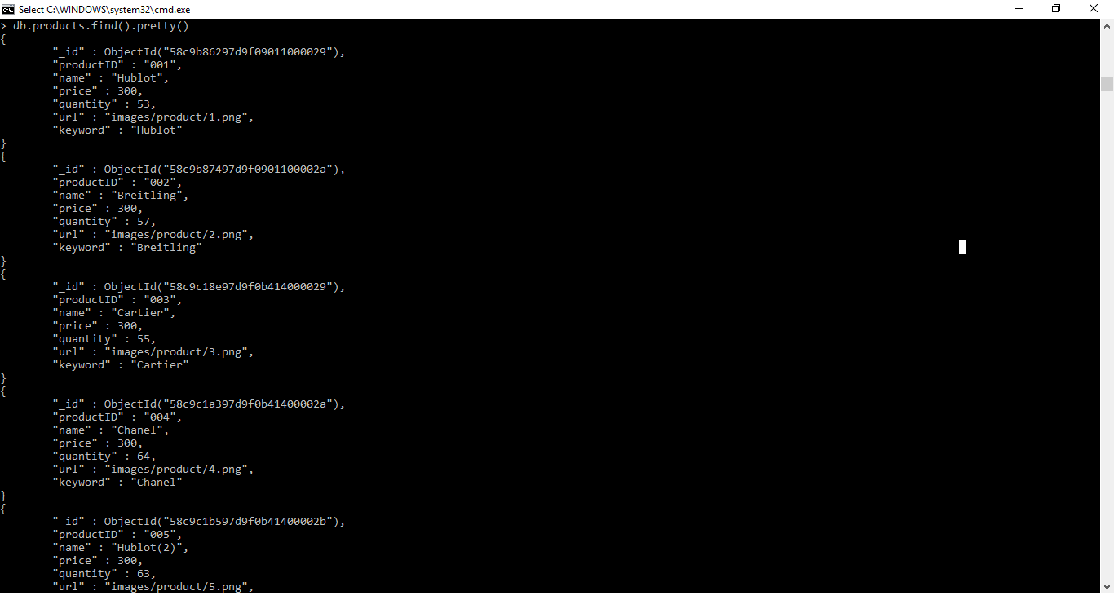

Product Table

**Security, Privacy and legal issues.**

By not asking a customer to alternatively log in with their Facebook or Gmail account we eliminate the risk of external hackers knowing personal information such as gender, address, driver’s license details, political views, personal pictures and many more. We also ask for only the required information such as an email address and to create a user Id and password for a more straightforward convenient registration.